CHAPTER 26
DIRECT CURRENT CIRCUITS
Discussion Questions
Q26.1 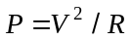 so the bulb with larger has smaller ; the resistance of the 120-W bulb is smaller. 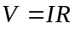 and in series the current is the same through each, so the 60-W bulb has a greater voltage drop. In parallel the voltages across each bulb will be the same.

Q26.2 The 25-W bulb has a larger resistance than the 200-W bulb (see Q26.1). In series the currents are the same so the voltage drop across the 25-W bulb is larger than that across the 200-W bulb. The voltage drops add to 240 V so the voltage across the 25-W bulb is larger than 120 V and the 25-W bulb is the one that burns out quickly. When the voltage across it is greater than 120 V it dissipates more than 25 W.

Q26.3 (i) series: More bulbs in series add to the total resistance of the circuit and this decreases the current. The brightness of each bulb decreases as bulbs are added in series. (ii) parallel: The full battery voltage is placed across each bulb in parallel, no matter how many bulbs there are. The brightness of each bulb is the same as more are added in parallel, if the internal resistance of the battery can be neglected.
In series the current through the battery is 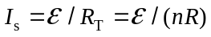 for bulbs of resistance . In parallel the current through the battery is 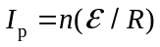. 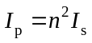. The total power delivered by the battery is 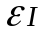 so the power is greater by a factor of 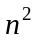 when the bulbs are connected in parallel. The battery lasts longer when the bulbs are in series.

Q26.4 The voltage across is and the voltage is 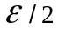 across and . has more current through it, more potential difference across it and is the brightest. If is unscrewed the voltages across and don’t change and the brightness of and don’t change. If is unscrewed there is no current path in that parallel branch and goes out. The voltages across is still and the brightness of doesn’t change.

Q26.5 (a) True. For resistors in series the current is the same in each resistor. The reason is conservation of charge. All the charge that flows through 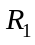 as must also flow through 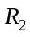 as 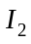. The current entering a resistor always equals the current leaving the resistor. (b) False. (c) False. 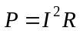 so 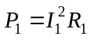 and 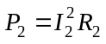. 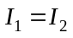 and 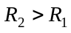 means that 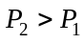. (d) True.
(e) False. 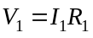 and 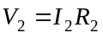. and so 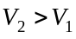. (f) False.  is the potential drop across a resistor. The end of the resistor where the current enters is at higher potential than the end where the current exits. 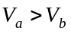and 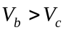. (g) False. (h) True.

Q26.6 (a) False. 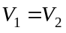 so 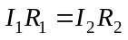. 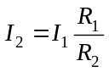. so 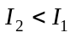. (b) True. At point a the current 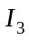 splits into and . At b, and combine to form 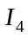. Conservation of charge says 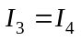. (c) True. (d) False. 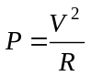. 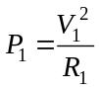 and 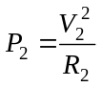. Since and , then 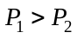. (e) False. (f) True. Points a, c and e are all at the same potential and points d, f and b are all at the same potential. (g) True. The potential difference between the ends of is 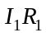 and the end where the current enters is at higher potential. (h) False. (i) False.

Q26.7 Since the battery has no internal resistance its terminal voltage is independent of the current through it and is equal to its emf . Closing the switch adds a third bulb in parallel to the other two. But the voltage across each bulb is and doesn’t change when the third bulb is connected. The brightness of bulbs 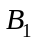 and 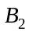 won’t change.

Q26.8 Decrease. The resistor is equivalent to three resistors in parallel. Adding resistors in parallel decreases the total resistance so cutting one of the strips and therefore changing from three resistors in parallel to two in parallel increases the overall resistance. Before the strip is cut, 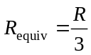. After the strip is cut, 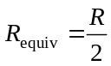. Since the resistance increases the current through the ammeter decreases.

Q26.9 Increase. Closing the switch adds another resistor in parallel to the resistor network and this reduces the resistance of the network and thereby the total resistance of the circuit. This increases the current through the light bulb.

Q26.10 Decreases. The voltage across the light bulb equals the terminal voltage of the battery. When the switch is closed the total equivalent resistance of the circuit decreases and the current through the battery increases. An increase in current through the battery causes the terminal voltage to decrease and the current through the light bulb decreases.

Q26.11 Won’t change. Since the battery has no internal resistance its terminal voltage equals its emf, independent of the current through the battery. The voltage across the bulb equals the terminal voltage of the battery, independent of whether the switch is open or closed. The current through the bulb doesn’t change when the switch is closed.

Q26.12 (a) Don’t change. Since the battery has no internal resistance its terminal voltage equals its emf, independent of the current through the battery. The voltage across the branches containing the bulbs equals the terminal voltage of the battery, independent of whether the switch is open or closed. The currents through the bulbs don’t change when the switch is closed. (b) Decrease. Now when the switch is closed and the current through the battery increases, the terminal voltage of the battery decreases.

Q26.13 Yes, it is possible. An example is shown in Fig. DQ26.13.

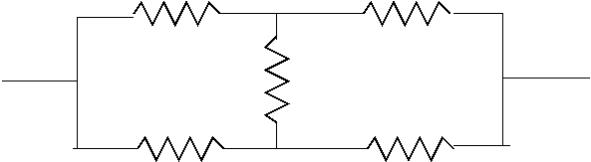

Figure DQ26.13

Q26.14 With t he switch open the bulbs are connected in series and they share the battery voltage: 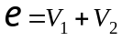. When the switch is closed the voltage across bulb becomes zero and no current flows through it. The voltage across becomes equal to the battery voltage and shines brighter.

Q26.15 For batteries in series the total voltage is the sum of the individual voltages. In parallel the voltage across the bulb is just the voltage of a single battery. In parallel the currents of the individual batteries add to give the total current, so more current can be delivered by batteries in parallel. Also, if one battery goes dead the others still deliver current to the device and the voltage applied to the device is unchanged.

Q26.16 With the switch open the three bulbs are connected in series and 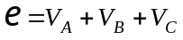. When the switch is closed the voltage across bulb becomes zero, no current flows through it and it goes out. And then 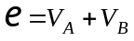. The voltages across and increase and they each shine brighter.

Q26.17 A voltmeter connected across the battery alone measured the emf. To check the internal resistance, use a voltmeter to measure the terminal voltage when the battery is connected in a circuit.

Q26.18 The time constant for an  charging circuit is 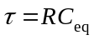, where 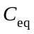 is the equivalent capacitance, For circuit (a), 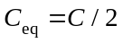. For circuit (b), 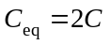. The time constant for circuit (a) is smaller and the capacitors charge at a faster rate than in circuit (b). The larger equivalent capacitance for circuit (b) means each capacitor holds more charge when fully charged so in (b) the capacitors take longer to reach their final charge.

Q26.19 The SI unit for R is . 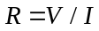 so 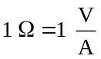. The SI unit for capacitance is F. 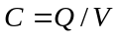 so 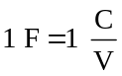. 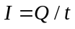 so  and 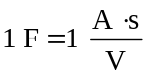. The product therefore has units 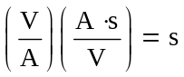, as was to be shown.
Q26.20 Measure the time constant by observing the current decay when a capacitor of known capacitance discharges through the resistor. Then 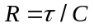.

Q26.21 When the capacitor is fully charged the battery emf equals the voltage across the capacitor. 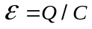 so 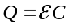 is the maximum charge. When the charging is complete there is no current through the resistor and the resistor plays no role. The resistor affects the rate at which the capacitor charges.

